IB Business Management
IA Proposal Guidance and Recommendations

2024 Subject report:
The IA is “a research project in which students apply appropriate business management tools and theories to a real organizational issue or problem using a conceptual lens” (subject guide, page 53). Put another way, the IA is the case study of a concept in the context of an organization, applying course contents to analyze and evaluate data drawn from a small number of key sources called “supporting documents” (SD). Linking concept, context and contents, this inquiry-based business research project embodies the pedagogical approach to the subject as described in the subject guide, page 11 and in the teacher support material (TSM, page 69 onwards).

Name of selected business

in the CONTEXT of an organization

Research question

in the CONTEXT of an organization

- In general, the narrower the research question is, the more likely it is that the student can answer the question thoroughly and in an in-depth fashion. However, the narrower the research question is, the harder it is to find three to five relevant supporting documents. Thus, the formulation of the research question and finding appropriate supporting documents are an iterative process that may take several attempts. (TSM)

- The best research questions are the ones where the student does not know the answer before the research process begins or the ones that cannot be answered with minimal research. The IAs of students with simplistic research questions that are easily answered often contain large amounts of material that is of marginal relevance. (TSM)

Key concept

Criterion A: Integration of a key concept (5 marks)
change, creativity, ethics, sustainability

case study of a CONCEPT

Big-picture thinking–“big ideas” embedded in key concept (TSM and Subject Report 2024, p. 7):
Each of these key concepts can be reduced to content, which is not what the IA asks of the students. Rather, in the IA, students should pick one key concept and reflect on how their project can shed light on the big ideas embedded in that key concept.

Key concept & RQ in Subject Report 2024, p. 7:
Although the word itself does not need to feature in the research question (RQ) itself, moderators noted
that many good IAs had the concept explicitly in the formulation of the RQ (either the word itself, or a
word of the same family: ethically, sustainable, changing etc). This may be encouraged as good practice
as it can help students focus their inquiry on their chosen concept.

Key Concept and formatting in Subject Report 2024, p.7:
Some students emboldened the concept throughout their text - this typographical technique is interesting and can indeed help students maintain their focus on the concept throughout the IA.

Theories and tools (3-5 you can apply to help answer your RQ)

Criterion C: Selection and application of tools and theories (4 marks)
IB Business Management Toolkit here

applying course CONTENTS

Used to develop answer to RQ: Once you are clear on your research question and supporting documents, you should now consider the business management tools and theories to be used in answering the question. (TSM)

Purposeful selection and application: Generally, when students are purposeful in their selection of tools and theories and apply them in depth in answering their research question, the students produce better IAs. An indiscriminate approach, where students use many different tools and theories very superficially, weakens the overall result of an IA. (TSM)

Criterion C: Selection and application of tools and theories in Subject Report 2024, p.9:
Most students obtained some marks for criterion C as they showed some subject knowledge, from business models (such as the Ansoff matrix and the Boston Consulting Group (BCG) matrix) to business practices (such as circular business models), and from business terminology (for example about stakeholders or pricing strategies) to business maths (e.g. descriptive statistics). [...] For 4 marks: “the business management tools and theories [must be] effectively selected and applied with clear relevance to the research question” (subject guide, page 57) and that relevance was sometimes absent.
Moderators sometimes had to lower the marks awarded to criterion C as the tools were rather generic (e.g.
SWOT analysis about any IA topic) and/or not clearly linked to the research question (e.g. a Gantt chart for
an IA about ethical decision-making).

Supporting documents (5 total)

Criterion B: Supporting Documents (4 marks) and Criterion D: Analysis and evaluation (5 marks)

to analyze and evaluate DATA drawn from a small number of key sources called “supporting documents”

Criterion D: Analysis and evaluation - Data must come from SDs [depth] - in Subject Report 2024, p.10: Just as some teachers and students missed or ignored the crucial notion of “relevance” for Criterion C (see above), some missed a key aspect of criterion D: the fact that it is about the use of data from the supporting documents.
Criterion B and Criterion D - Select SDs for quality of data [suitability] - in Subject Report 2024: There is a partial correlation between criterion B and criterion D: if the SD lack depth or are only marginally relevant (therefore achieving a low mark for B), they are not going to provide helpful data for the analysis (therefore achieving a low mark for D as well). [...] Highlighting the passages of the SD used or quoted in the IA is a crucial step meant to help students select the data they require for their analysis: if a SD has very little highlighted, is it the most suitable SD to contribute to the analysis?
Select SDs that provide “a range of ideas and views” [breadth] in Subject Report 2024, p.8: Concretely, this could mean the views of both internal and external stakeholders, or of both the proponents and opponents of a project, or a combination of qualitative data and quantitative data. Depending upon the research question, this “range of points of views” could also be achieved by media articles from different countries or in different languages (duly translated) or from business news channels that have different (political, ideological) opinions; or the findings from secondary research vs the findings from primary research (some students used very well the outcomes from their own primary research as SDs, for example the transcript of an interview or the results of a survey that they carried out).
Selecting SDs that are “authentic documents” vs. not suitable documents in Subject Report 2024, p.8: The aim of the IA is to engage students with authentic documents (written for an audience other than business students). A ready-made SWOT, PESTLE or marketing mix analysis downloaded from the internet is not suitable [...] Other sources that are not suitable for SD include: pages from Wikipedia, pages from Encyclopaedia Britannica, extracts from textbooks and screenshots of e-books, extracts from university students’ theses. (A thesis written by a university student can be a very good starting point, but the student should then use its bibliography to find suitable SDs for their IA).
RQ and selection of primary or secondary research in SDs: In general, though not mandatory, a project based mostly upon primary research should have a forward-looking research question and projects based mostly on secondary research should have a backward-looking research question. (TSM)
Length of SDs: Excerpt if longer than five pages.
Three-year contemporary rule: Each of the supporting documents must be dated and not over three years old since the submission date to the IB = 20th April 2022.

Start with more than 5 SDs to select from: Ideally, students should find more than five documents that could potentially be used as supporting documents, but then cut the list down to five. The other documents can be used as sources for the research project, though they should not be included with the supporting documents when the IA is submitted. (TSM)

More on selecting Primary and Secondary sources for SDs

Primary Sources for SDs
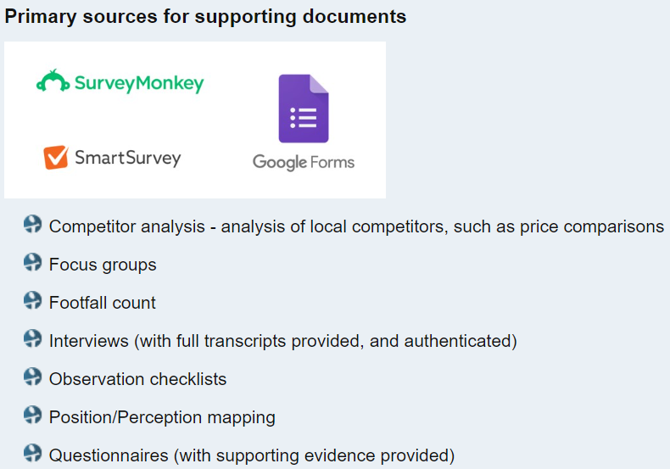(ThinkIB)

IB guide: Primary sources provide first-hand information or direct evidence for the research. Examples of primary sources include:
• face-to-face and online surveys/questionnaires; students should include a blank copy of the questionnaire and a tally/summary of responses
• face-to-face and online interviews; students should include a copy of the interview questions and summary of the responses
• focus group discussions; students should include a copy of the focus group questions and summary of the findings.
Documentation for primary data collection must be included in your “Supporting Documents.” Documentation includes details and instruments for collecting data and the data collected.
All of these could be done in person or remotely using online tools and technologies, such as video conferencing, shared documents or survey software.

What do suitability, breadth, and depth mean for your primary sources?
For primary sources, suitability would mean you have documented and collected relevant data in an acceptable business research form, such as those listed above. Breadth means you either engage in broad sampling for your data (number of surveys or questionnaires, length and variety of observations), or use primary data to engage a range of perspectives or perspective(s) different from those in your other sources. Depth means you designed your primary research to yield significant results and thoughtfully consider the connections or implications.

Secondary Sources for SDs (ThinkIB)
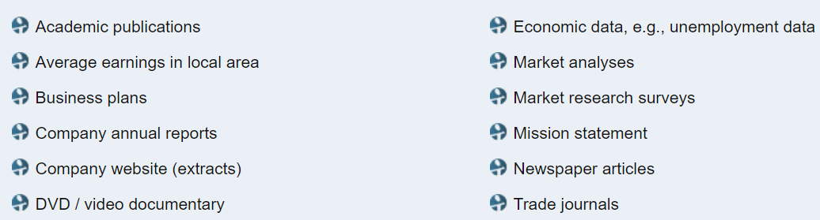
(Each of the supporting documents must be dated and not over three years old since the submission date to the IB = 20th April 2022)

IB guide: Secondary sources provide second-hand information or already existing data for the research. Examples of secondary sources include:
• articles from the respected local, national or international press
• business accounts
• business plans
• extracts from company websites
• transcripts of a relevant audio-visual file
• financial reports
• government and other statistics
• academic and trade journal publications
• market research surveys
• mission statements.

What do suitability, breadth, and depth mean for your secondary sources?
For secondary sources, suitability means you have found reliable business research sources with relevant information that have been published since April 20, 2022 (Highlight the relevant information when you include the source in the “Supporting Documents” section.) Breadth means your sources represent more than one perspective or a variety of considerations related to the issue or problem the company faces. Depth means the source provides enough information for you to breakdown in analysis and draw significant conclusions from.

Final tips for SDs from Kognity (6.1.2)
Good supporting documents should:
- Be varied secondary and/or primary sources. It is fine to use exclusively secondary sources for the internal assessment. You can achieve full marks with secondary sources. However, if you can use one or more primary sources, this can help you add variety and perspective to your supporting documents. The sources should be varied in type.
- Be useful, providing all or almost all the information you need. You should not be taking much, if any, information from sources beyond the three to five supporting documents. The supporting documents should provide information that you can use with the theories/tools you have selected.
- Be valid/reliable. You should only use credible sources. If you are unsure about the credibility of a source, consult your teacher.

